Deerwalk Institute Of Technology
Database Administration

Lab: 6

Submitted By: Submitted To:
Name: Sagar Giri Narayan Chalise
Roll No. 205

Date:
Managing Privileges
- System Privilege

- Assign CREATE SESSION Privilege to the user.

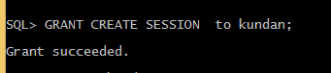

- Trying to grant the CREATE SESSION Privilege to another user by kundan and failed because kundan is not granted with the ADMIN OPTION.

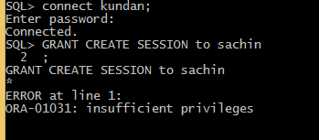

- Create user and role and assign that user to that role.

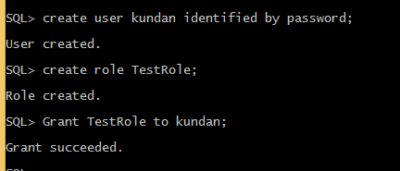

- Grant CREATE SESSION Privilege to the TestRole, though kundan will also get that Privilege.

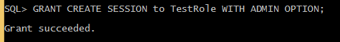

- Trying to grant the CREATE SESSION Privilege to another user by kundan and success because TestRole is granted with the ADMIN OPTION and kundan is assigned to the TestRole.

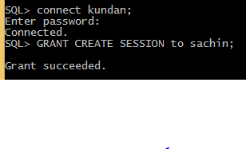

- Object Privilege

- Granting select privilege on the student table of user prajjwal to the user kundan without GRANT OPTION.

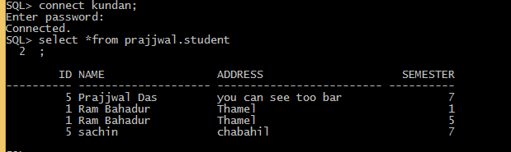

- Trying to use delete query by kundan on user prajjwal’s student table but failed.

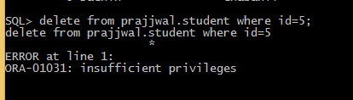

- Trying to GRANT the select privilege on the student table of user prajjwal to the user sachin by kundan but failed.

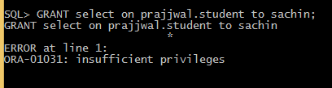

- Granting select privilege on the student table of user prajjwal to the user kundan with GRANT OPTION.

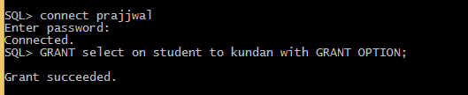

- Trying to GRANT the select privilege on the student table of user prajjwal to the user sachin by kundan and successes.

